Eckerd Connects Project Bridge C6 March Calendar | 2019
Sunday | Monday | Tuesday | Wednesday | Thursday | Friday | Saturday
 |  |  |  |  | 1 | 2
3 | 4 | 5 | 6 | YMCA/Mentors 7 | Boys Court 8 | 9
 | Contact C6 TSS for YMCA, mentoring and Employment Workshop times | Contact C6 TSS for YMCA, mentoring and Employment Workshop times | Contact C6 TSS for YMCA, mentoring and Employment Workshop times |  | 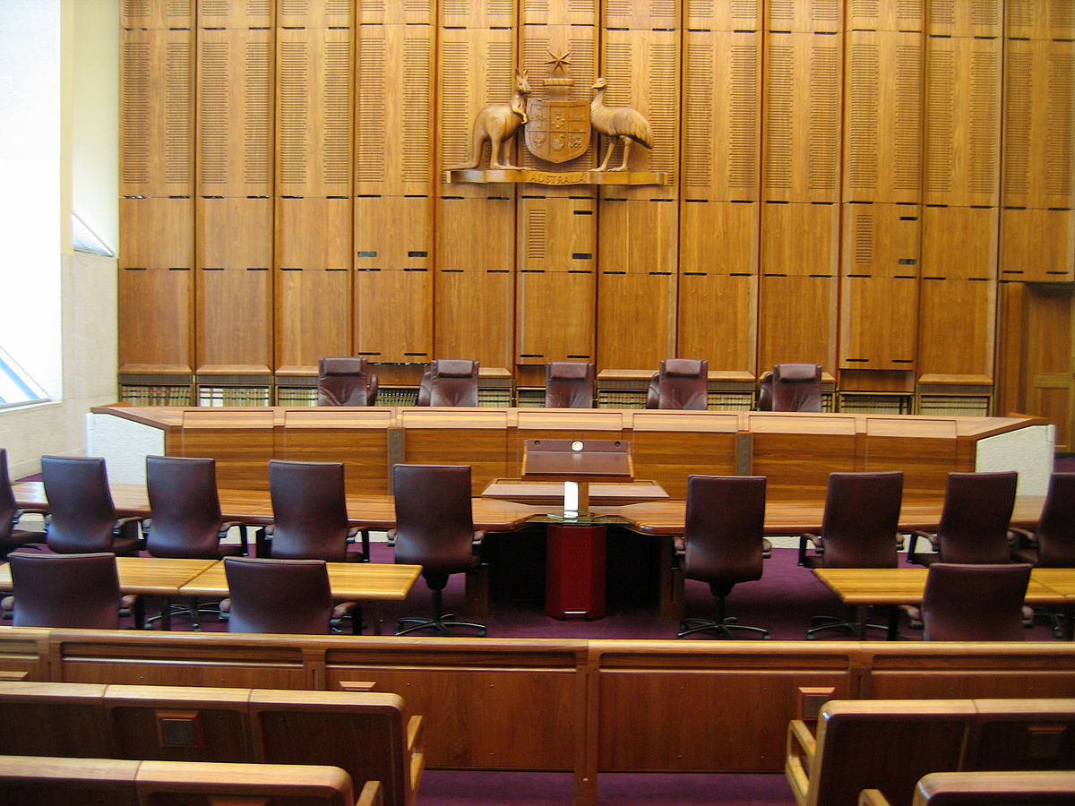  This Photo by Unknown Author is licensed under CC BY-SA
10 | 11 | 12 | JLM Studios 13 | YMCA/Mentors 14 | 15 | 16
 | Contact C6 TSS for YMCA, mentoring and Employment Workshop times | Contact C6 TSS for YMCA, mentoring and Employment Workshop times | 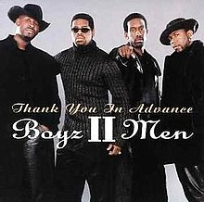  This Photo by Unknown Author is licensed under CC BY-SA
17 | Fishing 18  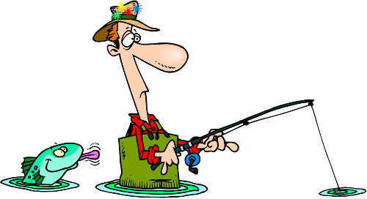  This Photo by Unknown Author is licensed under CC BY-SA-NC | Spring 19  Training  This Photo by Unknown Author is licensed under CC BY-SA | 20  PlayStation Challenge/JLM  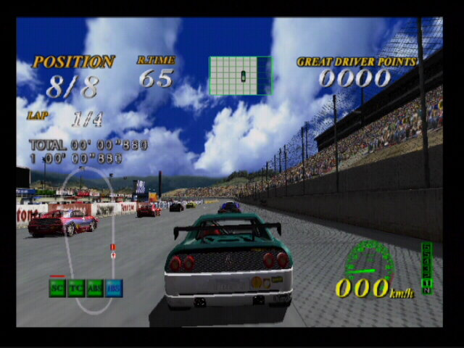  This Photo by Unknown Author is licensed under CC BY-SA-NC | 21  HCC Field Trip  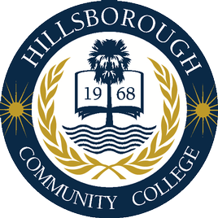  This Photo by Unknown Author is licensed under CC BY-SA | Boys Court 22  This Photo by Unknown Author is licensed under CC BY-SA  Ronald McDonald House Care | 23
24  This Photo by Unkno CC BY | 25  Amskills  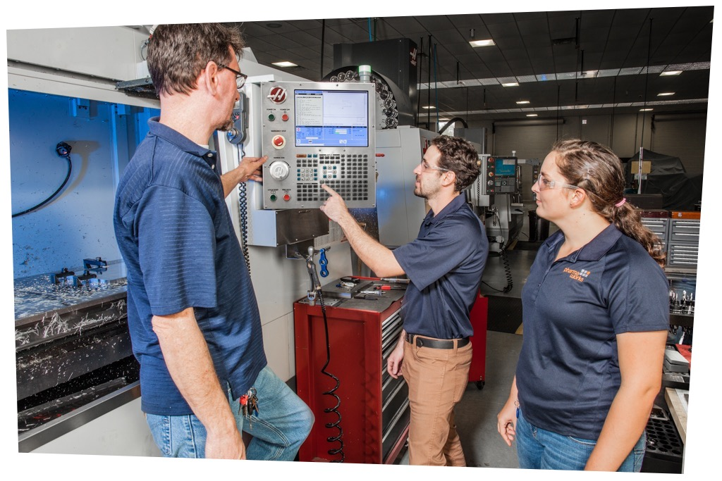 | 26  Contact C6 TSS for YMCA, mentoring and Employment Workshop times | 27  Contact C6 TSS for YMCA, mentoring and Employment Workshop times | 28 | 29 | 30
 | This Photo by Unknown Author is licensed under CC BY-SA |  |  |  | Insurance Tour
31
Boys Court
Friday 03/08 & 03/22 2pm-3:30pm
Email Mmouzon@Eckerd.org for more information

Boyz 2 Men Wednesday 03/13/19 4pm-6:00pm
Email Mmouzon@Eckerd.org for more information

Inspirational Movie & Popcorn
Friday 03/15 12pm – 2:00pm Email: TaShannon@Eckerd.org for more information

YMCA Palm Harbor/Flag Football
Every Thursday’s 6:00pm – 8:00pm Email Mmouzon@Eckerd.org for more information

Spring Break Fishing
Monday 03/18 10:00am – 1pm
Email: ASmith@Eckerd.org for more information

Spring Basketball Training
Tuesday 03/19 2:pm – 3:pm Email: ChriJohnson@Eckerd.org
for more information

Play Station Challenge Wednesday 03/20 2:pm – 4:pm Email: Mmouzon@Eckerd.org

HCC Field Trip Thursday 03/21 6:00pm – 8:00pm Email: VSeavey@Eckerd.org for more information

Ronald McDonald House Care
Friday 03/22 12pm – 2:00pm Email: LLopez@Eckerd.org for more information
Youth to Men
Youth Community Outreach Sunday 03/24 11:am – 2:pm Email: TaShannon@Eckerd.org for more Information

Amskills
Monday 03/25 2:pm – 4pm
Email Mmouzon@Eckerd.org for more information

Youth Leadership Luncheon
Friday 02/08/19 11:30am-2pm
Email AlSmith@eckerd.org for more information

Job Corps
Monday 02/11/19 12pm-2pm
Email BKelling@HBI.org for more information

USF Valentine’s Day Party Wednesday 02/13/19 4pm-6:00pm
Emafor more information

Boy’s Court
Friday 02/22/19 2:30am – 3:30pm
Email Mmouzon@Eckerd.org for more information

MADD
Tuesday 02/26/2019 2:00pm – 3:00pm Email Mmouzon@Eckerd.org for more information

Youth to Men Mentoring Event
02/27/19 4pm-6pm
Email Mmouzon@Eckerd.org for more information

Basketball Game W/Mentor Sarah
02/27/19 7pm – 9pm Email CMalolos@Eckerd.org for more information.
Inspire Studio Music Production and Mentoring
Monday 02/04 & 02/18 4-6pm
Email Mmouzon@Eckerd.org for more information

Youth Leadership Luncheon
Friday 02/08/19 11:30am-2pm
Email AlSmith@eckerd.org for more information

Job Corps
Monday 02/11/19 12pm-2pm
Email BKelling@HBI.org for more information

USF Valentine’s Day Party Wednesday 02/13/19 4pm-6:00pm
Email CMalolos@Eckerd.org for more information

YMCA Palm Harbor/Flag Football
Every Thursday’s 6:00pm – 8:00pm & Saturday’s 12:00pm – 3:30pm Email Mmouzon@Eckerd.org for more information

Boy’s Court
Friday 02/22/19 2:30am – 3:30pm
Email Mmouzon@Eckerd.org for more information

MADD
Tuesday 02/26/2019 2:00pm – 3:00pm Email Mmouzon@Eckerd.org for more information

Youth to Men Mentoring Event
02/27/19 4pm-6pm
Email Mmouzon@Eckerd.org for more information

Basketball Game W/Mentor Sarah
02/27/19 7pm – 9pm Email CMalolos@Eckerd.org for more information.

