C13 Project Bridge December sPECIAL eVENTS
Boxing and Mentoring with Jerry
12/3 and 12/17 2:00-3:00pm
Email TaShannon@Eckerd.org for more information
·
Sport Carlo @ the Unearthed Event
12/08/18 11am-1pm
Email CMalolos@Eckerd.org for more information
·
Youth to Men Mentoring Event
12/12/18 4pm-6pm
Email Mmouzon@Eckerd.org for more information
·
Music and Mentoring with Jerry
1Every Wednesday 2:30-4:00pm
Email TaShannon@Eckerd.org for more information

Saturday Outreach
12/15/18 11:30am-1pm
Email TaShannon@Eckerd.org for more information

USF Christmas Party
12/18/18 4pm-6:00pm
Email Mmouzon@Eckerd.org for more information

Tabitha’s Marvelous Movie Night
12/28/18 12-2pm
Email TaShannon@Eckerd.org for more information

Sunday | Monday | Tuesday | Wednesday | Thursday | Friday | Saturday
 |  |  |  |  |  | 1
2 | 3 | 4 | 5 | 6 | 7 | 8
 |  | Contact C13 TSS staff for GED schedule. (813 ) 955-3550 | 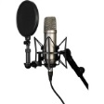 | Contact C13 TSS staff for GED schedule. (813 ) 955-3550 | Contact C13 TSS staff for GED schedule. (813 ) 955-3550 | 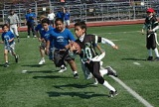
9 | 10 | 11 | 12 | 13 | 14 | 15
 |  | Contact C13 TSS staff for GED schedule. (813 ) 955-3550 | 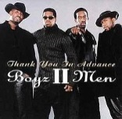 | Contact C13 TSS staff for GED schedule. (813 ) 955-3550 | Contact C13 TSS staff for GED schedule. (813 ) 955-3550
16 | 17 | 18  18 | 19 | 20 | 21 | 22
 |  |  |  | Contact C13 TSS staff for GED schedule. (813 ) 955-3550 | Contact C13 TSS staff for GED schedule. (813 ) 955-3550
23 | 24 | 25 | 26 | 27 | 28 | 29
 | CLOSED | CLOSED | Contact C13 TSS staff for GED schedule. (813 ) 955-3550 | Contact C13 TSS staff for GED schedule. (813 ) 955-3550 | 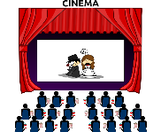
30 | 31
 | Contact C13 TSS staff for GED schedule. (813 ) 955-3550

