Sunday | Monday | Tuesday | Wednesday | Thursday | Friday | Saturday
 |  |  |  |  | 1 | 2
 |  |  | C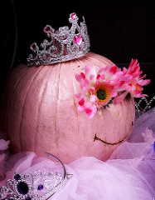09
3 | 4 | 5 | 6 | 7 | 8 | 9
 | GED/Tutoring Services  Employability/ Life Skills | GED/Tutoring Services  Employability/ Life Skills | Employability/ Life Skills | GED/Tutoring Services  Employability/ Life Skills |  | MY FEST
10 | 11 | 12 | 13 | 14 | 15 | 16
 | GED/Tutoring Services  Employability/ Life Skills  Job Corps | GED/Tutoring Services  Employability/ Life Skills  Clean The World  This Photo by Unknown Author is licensed under CC BY-NC | Employability/ Life Skills | GED/Tutoring Services  Employability/ Life Skills
17 | 18 | 19 | 20  Zach and Megan’s Second Annual Spring Break | 21 | 22 | 23
 | Air Boat Ride  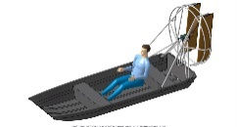  This Photo by Unknown Author is licensed under CC BY-SA | GED/Tutoring Services  St. Patrick’s Bingo! | Science Center  This Photo by Unknown Author is licensed under CC BY-NC-ND | 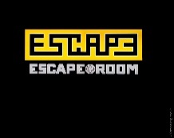  This Photo by Unknown Author is licensed under CC BY-NC-ND | PARTY IN THE USA BBQ  This Photo by Unknown Author is licensed under CC BY
24 | 25 | 26 | 27 | 28 | 29 | 30
 | GED/Tutoring Services  Employability/ Life Skills | GED/Tutoring Services  Employability/ Life Skills | Employability/ Life Skills | GED/Tutoring Services  Employability/ Life Skills
C9 March 2019 EVENTS
GED Life Skills
Eckerd Connects Project Bridge Central
Monday, Tuesday, Thursday
10:30am to 12:30pm

EMPLOYABILITY Life Skills
Tuesday & Thursday
10am to 12:30p - 1pm to 3pm
Monday, Wednesday
3pm & 5pm

My Fest
March 9th, 2019
11AM-3PM

Clean The World
March 12th, 2019
12:35-3PM

Air Boat Ride
March 18th, 2019
11AM

St Patrick’s Bingo at Nursing Home
March 19th, 2019
1PM

Orlando Science Center
March 20th, 2019
Time TBD

Escape Room
March 21st, 2019
Time TBD

Party in the USA BBQ
March 22nd, 2019
11AM

