Sunday | Monday | Tuesday | Wednesday | Thursday | Friday | Saturday
 |  |  |  |  | 1 | 2
 |  |  | C09
3 | 4 | 5 | 6 | 7 | 8 | 9
 | GED/Tutoring Services  Employability/ Life Skills | GED/Tutoring Services  Employability/ Life Skills | Employability/ Life Skills | GED/Tutoring Services  Employability/ Life Skills
10 | 11 | 12 | 13 | 14 | 15 | 16
 | GED/Tutoring Services  Employability/ Life Skills  Job Corps | GED/Tutoring Services  Employability/ Life Skills | Employability/ Life Skills | GED/Tutoring Services  Employability/ Life Skills | Self Defense Class  This Photo by Unknown Author is licensed under CC BY-NC-ND
17 | 18 | 19 | 20 | 21 | 22 | 23
 | GED/Tutoring Services  Employability/ Life Skills | GED/Tutoring Services  Employability/ Life Skills  A Sense of Etiquette  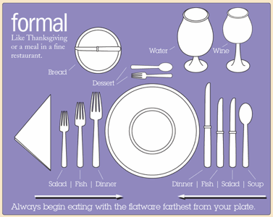  This Photo by Unknown Author is licensed under CC BY-ND | Employability/ Life Skills | GED/Tutoring Services  Employability/ Life Skills  Black History Celebration  This Photo by Unknown Author is licensed under CC BY-SA | Youth to Leaders  This Photo by Unknown Author is licensed under CC BY-NC
24 | 25 | 26 | 27 | 28
 | GED/Tutoring Services  Employability/ Life Skills | GED/Tutoring Services  Employability/ Life Skills  Black History Celebration | Employability/ Life Skills | GED/Tutoring Services  Employability/ Life Skills
C9 February 2019 EVENTS
GED Life Skills
Eckerd Connects Project Bridge Central
Monday, Tuesday, Thursday
10:30am to 12:30pm

EMPLOYABILITY Life Skills
Tuesday & Thursday
10am to 12:30p - 1pm to 3pm
Monday, Wednesday
3pm & 5pm

A Sense of Etiquette
Orlando Office
2/19/19
12:30-2PM

Black History Celebration
Orlando Office

2/21/19 – Jeopardy
10-12PM

2/26/19 – Guest Speaker/Speech
Writing
10-12:30

Job Corps
Tampa
9AM-4PM

Youth to Leaders
Orlando Office
2/22/19
3-5PM

Self Defense Class
Orlando Office
2/15/19
12-2PM

